NUnit and Moq

Objective:
Develop a unit-testable mail communication module using NUnit and Moq. The project demonstrates dependency injection and mocking to isolate external dependencies while testing the mail sending functionality without connecting to a real mail server.
Project Structure:
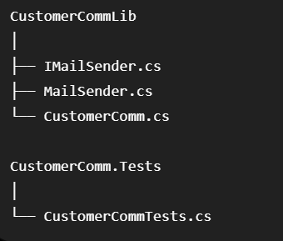
Implementation:
MailSender.cs:
namespace CustomerCommLib
{
public interface IMailSender
{
bool SendMail(string toAddress, string message);
}

public class MailSender : IMailSender
{
public bool SendMail(string toAddress, string message)
{
return true;
}
}
}
CustomerComm.cs:
namespace CustomerCommLib
{
public class CustomerComm
{
private IMailSender _mailSender;

public CustomerComm(IMailSender mailSender)
{
_mailSender = mailSender;
}

public bool SendMailToCustomer()
{
return _mailSender.SendMail("cust123@abc.com", "Some Message");
}
}
}
CustomerCommTests.cs:
using Moq;
using NUnit.Framework;
using CustomerCommLib;

namespace CustomerComm.Tests
{
[TestFixture]
public class CustomerCommTests
{
private Mock<IMailSender> mockMailSender = null!;

[OneTimeSetUp]
public void Init()
{
mockMailSender = new Mock<IMailSender>();
}

[TestCase]
public void SendMail_ReturnsTrue()
{
// Arrange
mockMailSender
.Setup(x => x.SendMail(It.IsAny<string>(), It.IsAny<string>()))
.Returns(true);

CustomerCommLib.CustomerComm customer =
new CustomerCommLib.CustomerComm(mockMailSender.Object);

// Act
bool result = customer.SendMailToCustomer();

// Assert
Assert.That(result, Is.True);
}
}
}

OUTPUT:
